Data Analytics Assignment-3

Super Store Sales Dash Board:

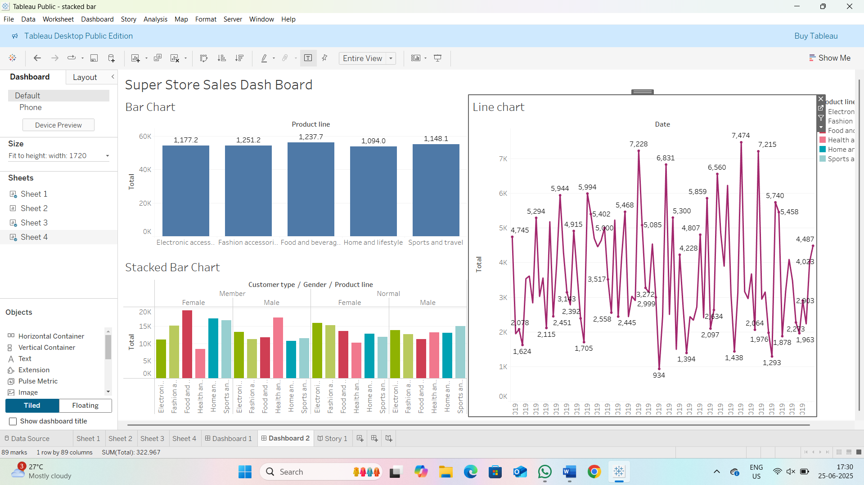

Super Store Profit Dash board:

